WELCOME
Patient Information

Date

First MI Last Age Sex: M F

Address Apt. Birth date
Patient SS#

City State Zip Cell #

Home # Work # Ext. E-Mail

Single Married Separated Divorced Widowed Best time & place to reach you

IN CASE OF EMERGENCY, CONTACT: Name Relationship
Home Phone Work Phone Ext
Whom may we thank for referring you?

Work Information

Occupation Phone Ext.

Company Address

Parent/ Spouse Information

Name SS# Birth date

Occupation Employer

Insurance

Who is responsible for this account? Relationship to patient
Insurance Co. Group # Injury related to:
Is patient covered by additional insurance? Yes No Motor vehicle accident Work comp.

Claim #:

Subscriber's name Birth date SS#

Relationship to patient Insurance Co. Group #

AUTHORIZATION
I certify that I have read and I understand the above information to the best of my knowledge. The above questions have been accurately
answered. I understand that providing incorrect information can be dangerous to my health. I authorize ChiroSport, PC to release any information including the diagnosis and the records of any treatment or examination rendered to me or my child during the period of such chiropractic care to third party payers and/or health practitioners. I authorize and request my insurance company to pay directly to the ChiroSport, PC insurance benefits otherwise payable to me. I understand that my chiropractic insurance carrier may pay less than the actual bill for services. I agree to be responsible for payment for all services rendered on my behalf or my dependents.

X Date
Patient's Signature (or parent if a minor)

ChiroSport, P.C. Financial Policy
Dear Patient:
Thank you for choosing us as your health care provider. The following is our financial policy. Our main concern is that you receive the proper and optimal treatments needed to restore your health. Therefore, if you have any questions or concerns about our payment policies, please do not hesitate to ask our office manager.
We ask that you read and sign our Financial Policy prior to seeing the doctor.
In special circumstances, we may accept an assignment of insurance benefits. However, you must understand that:
1. Your insurance policy is a contract between you, your employer and the insurance company.
We are NOT a party to that contract. Our relationship is with you, not your insurance company.
2. All charges are your responsibility whether your insurance company pays or not. Some insurance companies select certain services they will not cover. Fees for these services are your responsibility; however we will attempt to make you aware of these situations as soon as possible.
3. Co-payments and co-insurance are due at the time of service. We accept cash, checks, Visa, MasterCard, and Discover. We will be happy to process your claim for reimbursement as long as you provide us with the proper insurance information.
4. If the insurance company does not pay your balance in full within 30 days, we ask that you contact the carrier to help speed things up.
5. If the insurance company does not pay in full within 45 days, we may require you to pay the balance due.
6. A charge of 1.5% monthly interest rate may be assessed on all balances over 90 days old.
We do understand that temporary financial problems may affect timely payment of your balance. We encourage you to communicate any such problems so that we can assist you in the management of your account.
Thank you for choosing us as your health care provider. We know there are many providers to choose from. We appreciate your trust in us and the opportunity to serve you.
Patient’s Signature ___________________________________ Date: ________________

Consent for Treatment
I, the undersigned, a patient in this office hereby authorize the doctors at ChiroSport P.C. (and whomever he may designate as his assistant(s) to administer treatment as necessary.
I also certify that no guarantee or assurance has been made to the results that may be obtained.
I understand and agree that health and accident insurance policies are an arrangement between an insurance carrier and me. Furthermore, I understand that this office will prepare any necessary reports and forms to assist me in making collections from the insurance company and that any amount authorized to be paid directly to this office will be credited to my account upon receipt. I will permit this office to endorse remittances for the conveyance of credit to my account. However, I clearly understand and agree that all services rendered to me are charged directly to me and that I am personally responsible for payment.
Patient’s Signature: _______________________________ Date: _______________

Acknowledgement or Receipt of Privacy Practices
I, have received a copy of ChiroSport P.C.’s Notice of Privacy Practices with an effective date of January 1, 2004.

Current Patient Condition

Reason for visit 1. When did your symptoms appear?
2.
3.
Progression of pain? Getting Better Getting worse Unchanging Unknown
Rate the severity of your pain on a scale of 1 (least pain) to 10 (severe pain) [circle one] 1 2 3 4 5 6 7 8 9 10

Type of pain: Sharp Dull Throbbing Numbness Aching Shooting
Burning Tingling Cramps Stiffness Swelling Other
How often do you have this pain? Is it often or does it come and go?

Does it interfere with your: Work Sleep Daily routine Recreation

Activities or movements that are painful to perform: Sitting Standing Walking Bending Lying down
Health History

Height Weight Number of Children
Are you recovering from a cold or flu? Are you pregnant?
Laboratory procedures performed (e.g., stool analysis, blood and urine chemistries, hair analysis, saliva, bone density):

Outcome
What types of therapy have you tried for this problem(s)?
Diet modification Podiatrist Vitamins/minerals Herbs Homeopathy Chiropractic

Acupuncture Conventional drugs Physical therapy Other

Medical: PCP/Internist Orthopedist Neurologist Neurosurgeon Physiatrist

Date of exam Practitioner name & contact

List current health problems for which you are being treated:

Current medications (prescription and/or over-the-counter):

Major hospitalizations, surgeries, injuries. Please list all procedures, complications (if any) and dates: Year Surgery, illness, injury Outcome

Circle the level of stress you are experiencing on a scale of 1 to 10 (1 being the lowest): 1 2 3 4 5 6 7 8 9 10
Identify the major causes of stress (e.g., job change, family status change, work related, finances, etc...)
Do you consider yourself: Underweight Overweight Just right Your weight now:

Have you had an unintentional weight loss or gain of 10 pounds or more in the last 3 months? Yes No
Is your job associated with potentially harmful chemicals (e.g., pesticides, radioactivity, solvents) or health and/or life threatening activities (e.g., fireman, farmer, miner)?

Do you experience any of these general symptoms EVERYDAY?

Shortness of breath Nausea Fecal incontinence Bleeding Insomnia

Headaches Vomiting Urinary incontinence Discharge Constipation

Dizziness Diarrhea Low grade fever Itching/rash Chronic pain/inflammation

Medical History |  |  |  | Health Habits |  | Current Supplements
- Arthritis |  | - Decreased sex drive |  | - Tobacco: # per day |  | - Multivitamin/mineral
- Allergies/hay fever |  | - Infertility |  | - Alcohol: |  | - Vitamin C
- Asthma |  | - Sexually transmitted disease |  | - Wine: # glasses/d or wk |  | - Vitamin E
- Alcoholism |  | - Other |  | - Liquor: #oz./d or wk |  | - EPA/DHA
- Alzheimer's disease |  | Medical (Women) |  | - Beer: # glasses/d or wk |  | - Evening primrose/GLA
- Autoimmune disease |  | - Menstrual irregularities |  | - Caffeine: |  | - Calcium, source
- Blood pressure problems |  | - Endometriosis |  | - Coffee: # 6oz. Cup/day |  | - Magnesium
- Bronchitis |  | - Infertility |  | - Tea: # 6oz. Cup/day |  | - Zinc
- Cancer |  | - Fibrocystic breasts |  | - Soda: # cans/day |  | - Minerals, describe
- Chronic fatigue syndrome |  | - Fibroids/ovarian cysts |  | - Other |  | - Friendly flora (acidophilus)
- Carpal tunnel syndrome |  | - Premenstrual syndrome (PMS) |  | - Water: # glasses/day |  | - Digestive enzymes
- Cholesterol - elevated |  | - Breast cancer |  |  |  | - Amino acids
- Circulatory problems |  | - Pelvic inflammatory disease |  | Exercise |  | - CoQ10
- Colitis |  | - Vaginal infections |  | - 5 - 7 days per week |  | - Antioxidants (lutein, resveratrol, etc.)
- Dental problems |  | - Decreased sex drive |  | - 3 - 4 days per week |  | - Herbs – teas
Depression Sexually transmitted disease 1-2 days per week Herbs - Extracts
Diabetes Other 45 min or more workout Chinese herbs
Diverticular Disease Age of first period 30- 45 min workout Ayurvedic herbs
Drug addiction Last genealogical exam Less than 30 min workout Bach flowers
Eating disorder Mammogram: + - Walk Protein shakes
Epilepsy PAP: + - Run, Jog, Jump rope Super foods
Emphysema Birth control (form) Weight lift Liquid meals
Eyes, ears, nose, throat problems # of children Swim Other
Environment sensitivities # of pregnancies Box
Fibromyalgia C-section Yoga Would you like to:
Food intolerance Surgical menopause Other Have more energy
Gastroesophageal reflux disease Menopause Nutrition & Diet Be stronger
Genetic disorder Date of last menstrual period Mixed food diet (animal & veg) Have more endurance
Glaucoma Length of cycle Vegetarian Increase your sex drive
Gout Interval between cycles Vegan Be thinner
Heart disease Changes in normal flow Salt restriction Be more muscular
Inflammatory bowel disease Fat restriction Improve your complexion
Irritable bowel syndrome Starch/ carbohydrate restriction Have stronger nails
Kidney or bladder disease Family Health History Other food restrictions: Have healthier hair
Learning disability Arthritis Be less moody
Liver or gall bladder disease (stones) Asthma Food Frequency Feel more motivated
Mental illness Alcoholism Servings per day: Be more organized
Migraine headaches Alzheimer’s disease Fruits Think more clearly, be more focused
Neurological problems Cancer Dark green or deep yellow veggies Improve memory
Sinus problems Depression Do better on tests
Thyroid trouble Diabetes Grains (unprocessed) No dependents on over-the-counter drugs
Obesity Drug addiction Beans, peas, legumes Stop using laxatives or stool softeners
Osteoporosis Glaucoma Dairy, eggs Be free of pain
Pneumonia Heart disease Meat, poultry, fish Sleep better
Sexually transmitted disease Infertility Have agreeable breath
Seasonal affective disorder Learning disabilities Eating Habits Have agreeable body odor
Skin problems Mental illness Skip breakfast Have stronger teeth
Tuberculosis Mental retardation Two meals/ day Have less colds and flus
Ulcer Migraine headaches One meal/ day Get rid of allergies
Urinary tract infection Neurological disorders Graze (small frequent meals) Reduce your risk of inherited disease
Varicose veins Obesity Eat on the run tendencies
Other Stroke Add salt to food
Suicide

Medical (Men)
Benign prostatic hyperplasia (BPH)
Prostate cancer

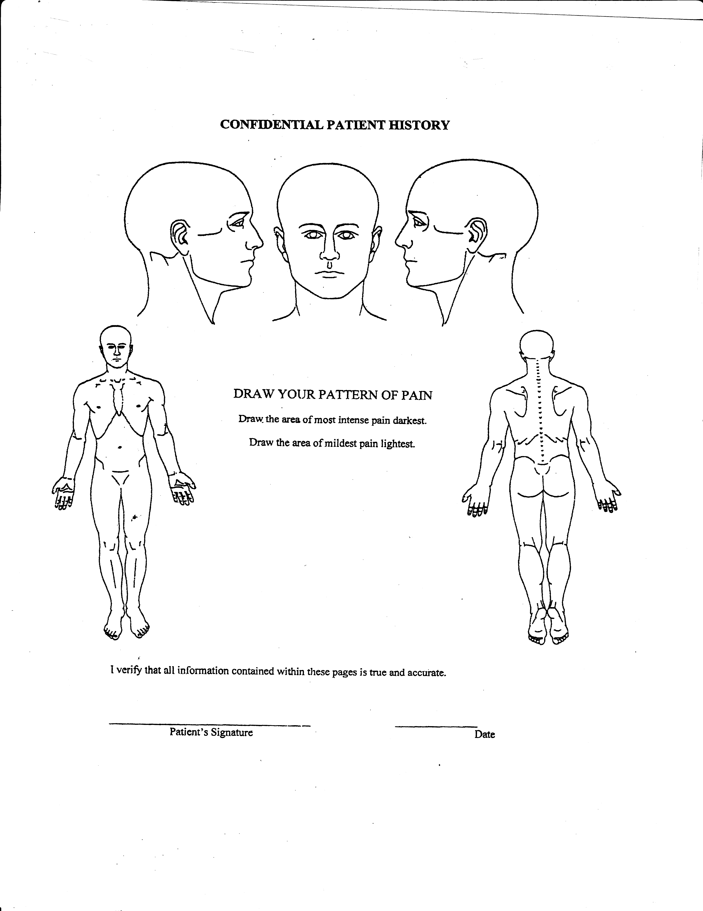

S-Sharp
B- Burning
D- Dull
T- Tingling
N- Numbness
- aching

